**Automatic Weather Station (AWS)**

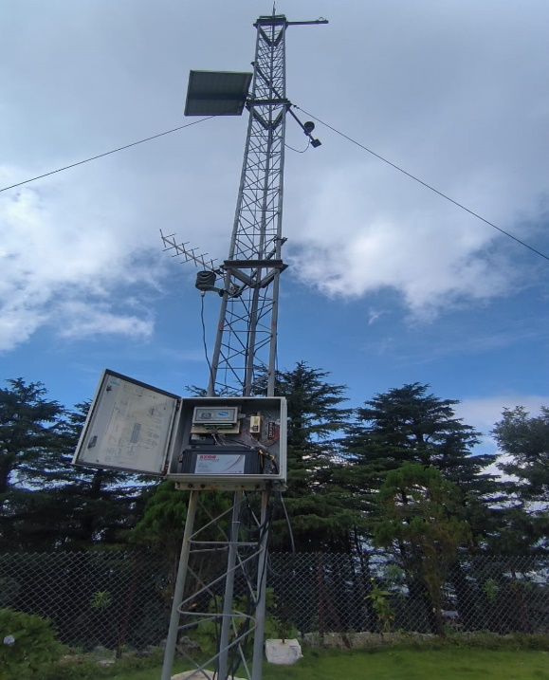

An **Automatic Weather Station (AWS)** is a system designed to automatically **measure, record, and transmit weather data** without human intervention. It continuously monitors meteorological parameters like temperature, humidity, wind speed, wind direction, solar radiation, atmospheric pressure, and rainfall. AWS units are widely used in **agriculture, aviation, environmental monitoring, and research**.

**Principle of AWS**

The AWS works on the principle of **sensing environmental changes using transducers and sensors**, converting them into electrical signals, which are then **digitally processed, recorded, and transmitted** to a central database or display system.

* **Sensors:** Each weather parameter is measured by a specific sensor (e.g., thermistor for temperature, anemometer for wind speed).
* **Signal Conversion:** Physical changes (temperature, pressure, etc.) are converted into electrical signals.
* **Data Logging:** The data logger collects, processes, and stores the data.
* **Transmission:** Data is transmitted via satellite, GSM, or internet to a central station for analysis.

### Working of AWS

### **Sensing:** Sensors continuously detect meteorological parameters. Example: A thermistor changes its resistance based on ambient temperature.

1. **Signal Conversion:** The sensor output (often analog) is converted to a digital signal using ADC (Analog-to-Digital Converter).
2. **Data Logging:** The microcontroller or data logger collects signals, timestamps them, and stores them in memory.
3. **Processing:** The raw signals are processed to convert them into meaningful units (°C, hPa, m/s, etc.).
4. **Transmission:** Data is sent to the central monitoring system using GSM, satellite, or radio frequency.
5. **Display & Analysis:** Data can be displayed locally on a screen or remotely on a web interface for further meteorological analysis.

**Components of AWS**

**1. DCP Enclosure (Data Collection Platform Enclosure)**

The DCP enclosure is a weatherproof protective box that houses all the electronic components of the AWS, such as the data logger, power supply, and transmitter. It safeguards the instruments from environmental factors like rain, dust, and high temperatures, ensuring stable operation and long life.

**2. Data Logger**

The data logger collects, stores, and processes data from various sensors like temperature, humidity, pressure, and wind sensors. It converts analog signals into digital form through the process of sampling and digitization and stores them with time stamps. it plays a key role in continuous and accurate weather data collection.

**3. Power Supply**

The power supply unit converts AC electricity into regulated DC power for AWS operation. It ensures stable voltage and current for all connected devices.

**Formula:**

P=V×I

**Convention:**

* P = Power (Watt)
* V = Voltage (Volt)
* I = Current (Ampere)

**4. Transmitter**

The transmitter sends recorded weather data to a remote server or central station. It works on the principle of radio frequency (RF) communication. The transmitter encodes the collected data into radio signals for wireless or satellite transmission.

**Principle:** Works on the principle of radio frequency communication — it converts weather data into signals and transmits them to a remote station.

**5. Battery**

The battery stores energy and supplies backup power to ensure the AWS works continuously even during power cuts. It works on the electrochemical energy storage principle.

**Formula:**

**E=V×Q**

**Convention:**

* E= Energy stored (Joule)
* V = Voltage (Volt)
* Q = Charge (Coulomb)

**6. Antenna**

The antenna is responsible for transmitting and receiving electromagnetic signals. It converts electrical signals from the transmitter into electromagnetic waves and vice versa.

**Formula:**

**c=f×λ**

**Convention:**

* c = Speed of light (m/s)
* f = Frequency (Hz)
* λ = Wavelength (m)

**7. GPS Antenna**

The GPS antenna determines the precise geographical location and provides time synchronization by receiving signals from satellites. It works on the principle of satellite triangulation. This ensures correct time-stamped data and exact station coordinates.

**8. Wind Speed and Direction Sensor (Anemometer and Wind Vane)**

The wind sensor measures the velocity and direction of the wind. The anemometer operates on Bernoulli’s principle and rotational motion.

**Formula:**

**v=(2πrN)/60**

**Convention:**

* v= Wind speed (m/s)
* r = Radius of rotation (m)
* N = Rotational speed (revolutions per minute)

**9. Global Radiation Sensor (Pyranometer)**

A pyranometer measures the solar radiation falling on a surface. It works on the thermoelectric or photovoltaic principle, converting sunlight into an electrical signal.

**Formula:**

**Q=σT4**

**Convention:**

* Q = Radiation energy (W/m²)
* σ = Stefan-Boltzmann constant (5.67 × 10⁻⁸ W/m²K⁴)
* T= Absolute temperature (K)

**10. Air Temperature and Relative Humidity Sensor**

This sensor measures ambient air temperature and relative humidity. Temperature measurement uses the resistance variation principle, while humidity measurement uses capacitive or resistive methods.

**Formula:**

**RH=(e/E) ×100**

**Convention:**

* RH = Relative Humidity (%)
* e = Actual vapor pressure (Pa)
* E = Saturation vapor pressure (Pa)

**11. Atmospheric Pressure Sensor (Barometer)**

The pressure sensor measures the atmospheric pressure exerted by the air column above it. It works on the hydrostatic principle or piezoelectric effect.

**Formula:**

**P= ρ*g*h**

**Convention:**

* P = Atmospheric pressure (Pa)
* ρ = Air density (kg/m³)
* g = Gravitational acceleration (m/s²)
* h = Height of air column (m)

**12. Rain Gauge Sensor**

A rain gauge measures the amount of precipitation over time. The tipping bucket type collects a fixed volume of water before tipping and generating a signal.

**Formula:**

**R=V/A**

**Convention:**

* R = Rainfall depth (m)
* V = Volume of collected water (m³)
* A = Collector area (m²)

**13. Solar Panel**

Solar panels convert sunlight into electrical energy using the photovoltaic effect. They supply power to the AWS and charge the backup battery.

**Formula:**

**P=V×I**

**Convention:**

* P = Electrical power generated (W)
* V = Voltage (V)
* I = Current (A)

**14. Remote Display Unit and Data Cartridge**

The remote display unit shows real-time weather data, and the data cartridge stores historical weather records. They receive processed data from the logger and are crucial for data retrieval and monitoring.